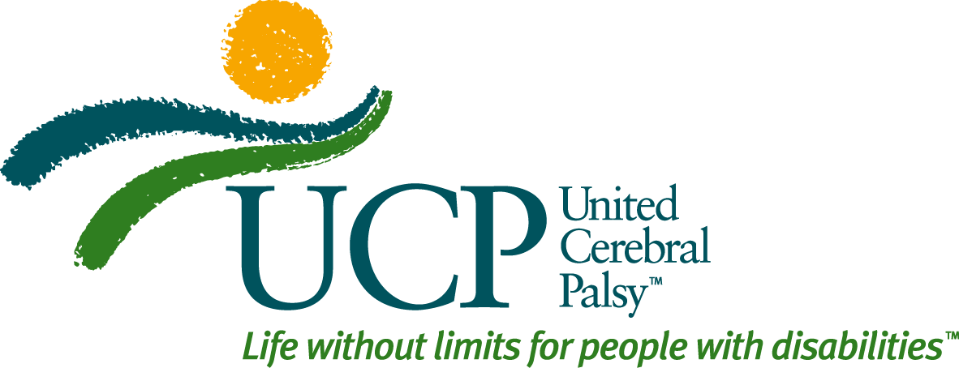

SPECIFIC LANGUAGE RECOMMENDATIONS IN RESPONSE TO RESEARCH FINDINGS
THE CORE MESSAGE FROM THE PERSPECTIVE OF UCP AND AFFILIATES
“People with disabilities and their families have the same goals as everyone else, even if they face different challenges. All of our work is concentrated on a single goal: ensuring people with disabilities and their families have the opportunities we all deserve. United Cerebral Palsy was founded in 1949 by family members of people with CP to help others overcome those challenges. Since then we’ve expanded our mission to unite and serve people with a broad range of disabilities, and their families – from those with Down syndrome to autism spectrum disorder to physical disabilities. We do this by working in communities, providing supports and services to more than 176,000 children and adults every day – one person at a time, one family at a time. We provide individuals and families with services like in-home care, transportation, and training. And we work to advocate for the common sense legislation to support and protect families. At UCP we believe that while we might face different challenges, we all share the same goals and we all deserve the opportunity to try to achieve them.”

- People think the status quo is pretty good. Talking about how bad things are falls on deaf ears.
SO, WHAT CAN WE DO? However, people respond to technological innovation because they see the benefits in action from communication to medical care. Garner support for IMPROVEMENTS in the status quo, especially with INNOVATIONS which might benefit the entire COMMUNITY such as increased employment, universal design, and inclusive classrooms that enrich students without disabilities with new experiences and the perspectives of students with disabilities.
- People don’t see a denial of rights for people with disabilities in the same light as in the fight for racial or LGBT equality. They don’t respond to calls to “fight” for the “rights” of people with disabilities or comparisons to other civil or human rights causes. They agree there is some social stigma but they feel that they PERSONALLY treat everyone equally. They’re offended that we might suggest otherwise!
SO, WHAT CAN WE DO? They want to see themselves as part of a universal community, not set apart from people who have “special needs.” They want to be invited – are, in fact eager! – to be part of a movement.
- People want us to acknowledge that we all have struggles to overcome. The struggles may be different but the goals are the same. We all want the same things out of life so we’re part of the same community. Don’t talk about the “disability community.”
SO, WHAT CAN WE SAY? People with disabilities and their families deserve OPPORTUNITIES to achieve their goals, just like everyone else. That’s a principle we all share as Americans. For people with disabilities opportunity means ACCESS to supports and services. Emphasize the human universals shared by people with and without disabilities alike. And, appeal to SHARED human experiences: family, community, productivity, knowledge, health, relationships, and happiness.
THE CORE MESSAGE FROM THE PERSPECTIVE OF PEOPLE WITH DISABILITIES
People with disabilities and their families have the same goals as everyone else, even if we face different challenges. No matter how different our backgrounds, it is the same things that make all of us happy and give our lives meaning. All of us, whether or no we have disabilities, want many of the same things. We want our families to be healthy and happy. We want meaningful work. And we all deserve the opportunity for us and our families to live meaningful lives.
Some people with disabilities and their families do need support in order to have the opportunity to achieve our goals. We may need a ramp to improve access to a school or office. Or a home health aide so the rest of the family can go out and earn a living. Whether you have a disability or not, we all face challenges. Ours might look a little different than yours. But our goals are not. We all deserve the opportunity to achieve those goals, for many of us that means ensuring access to supports and services.

- People want to hear about the breadth of who we serve and what we do, especially when it includes families, but they want language that is INCLUSIVE, not EXCLUSIVE. However, they expect to hear SPECIFICS of what we do and know that we have a FOCUS to our mission.
SO, WHAT CAN WE SAY? Focus on UCP’s Core Message: People with disabilities and their families have the same goals as everyone else, even if they face different challenges. All of our work is concentrated on a single goal: ensuring people with disabilities and their families have the opportunities we all deserve. United Cerebral Palsy was founded in 1949 by family members of people with CP to help others overcome those challenges. Since then we’ve expanded our mission to unite and serve people with a broad range of disabilities, and their families – from those with Down syndrome to autism spectrum disorder to physical disabilities. We do this by working in communities, providing supports and services to more than 176,000 children and adults every day – one person at a time, one family at a time. We provide individuals and families with services like in-home care, transportation, and training. And we work to advocate for the common sense legislation to support and protect families. At UCP we believe that while we might face different challenges, we all share the same goals and we all deserve the opportunity to try to achieve them.

© United Cerebral Palsy, 2014

